**Power-On-Connect Feature in Azure Windows Virtual Desktop and custom role for Power On Connect preview**

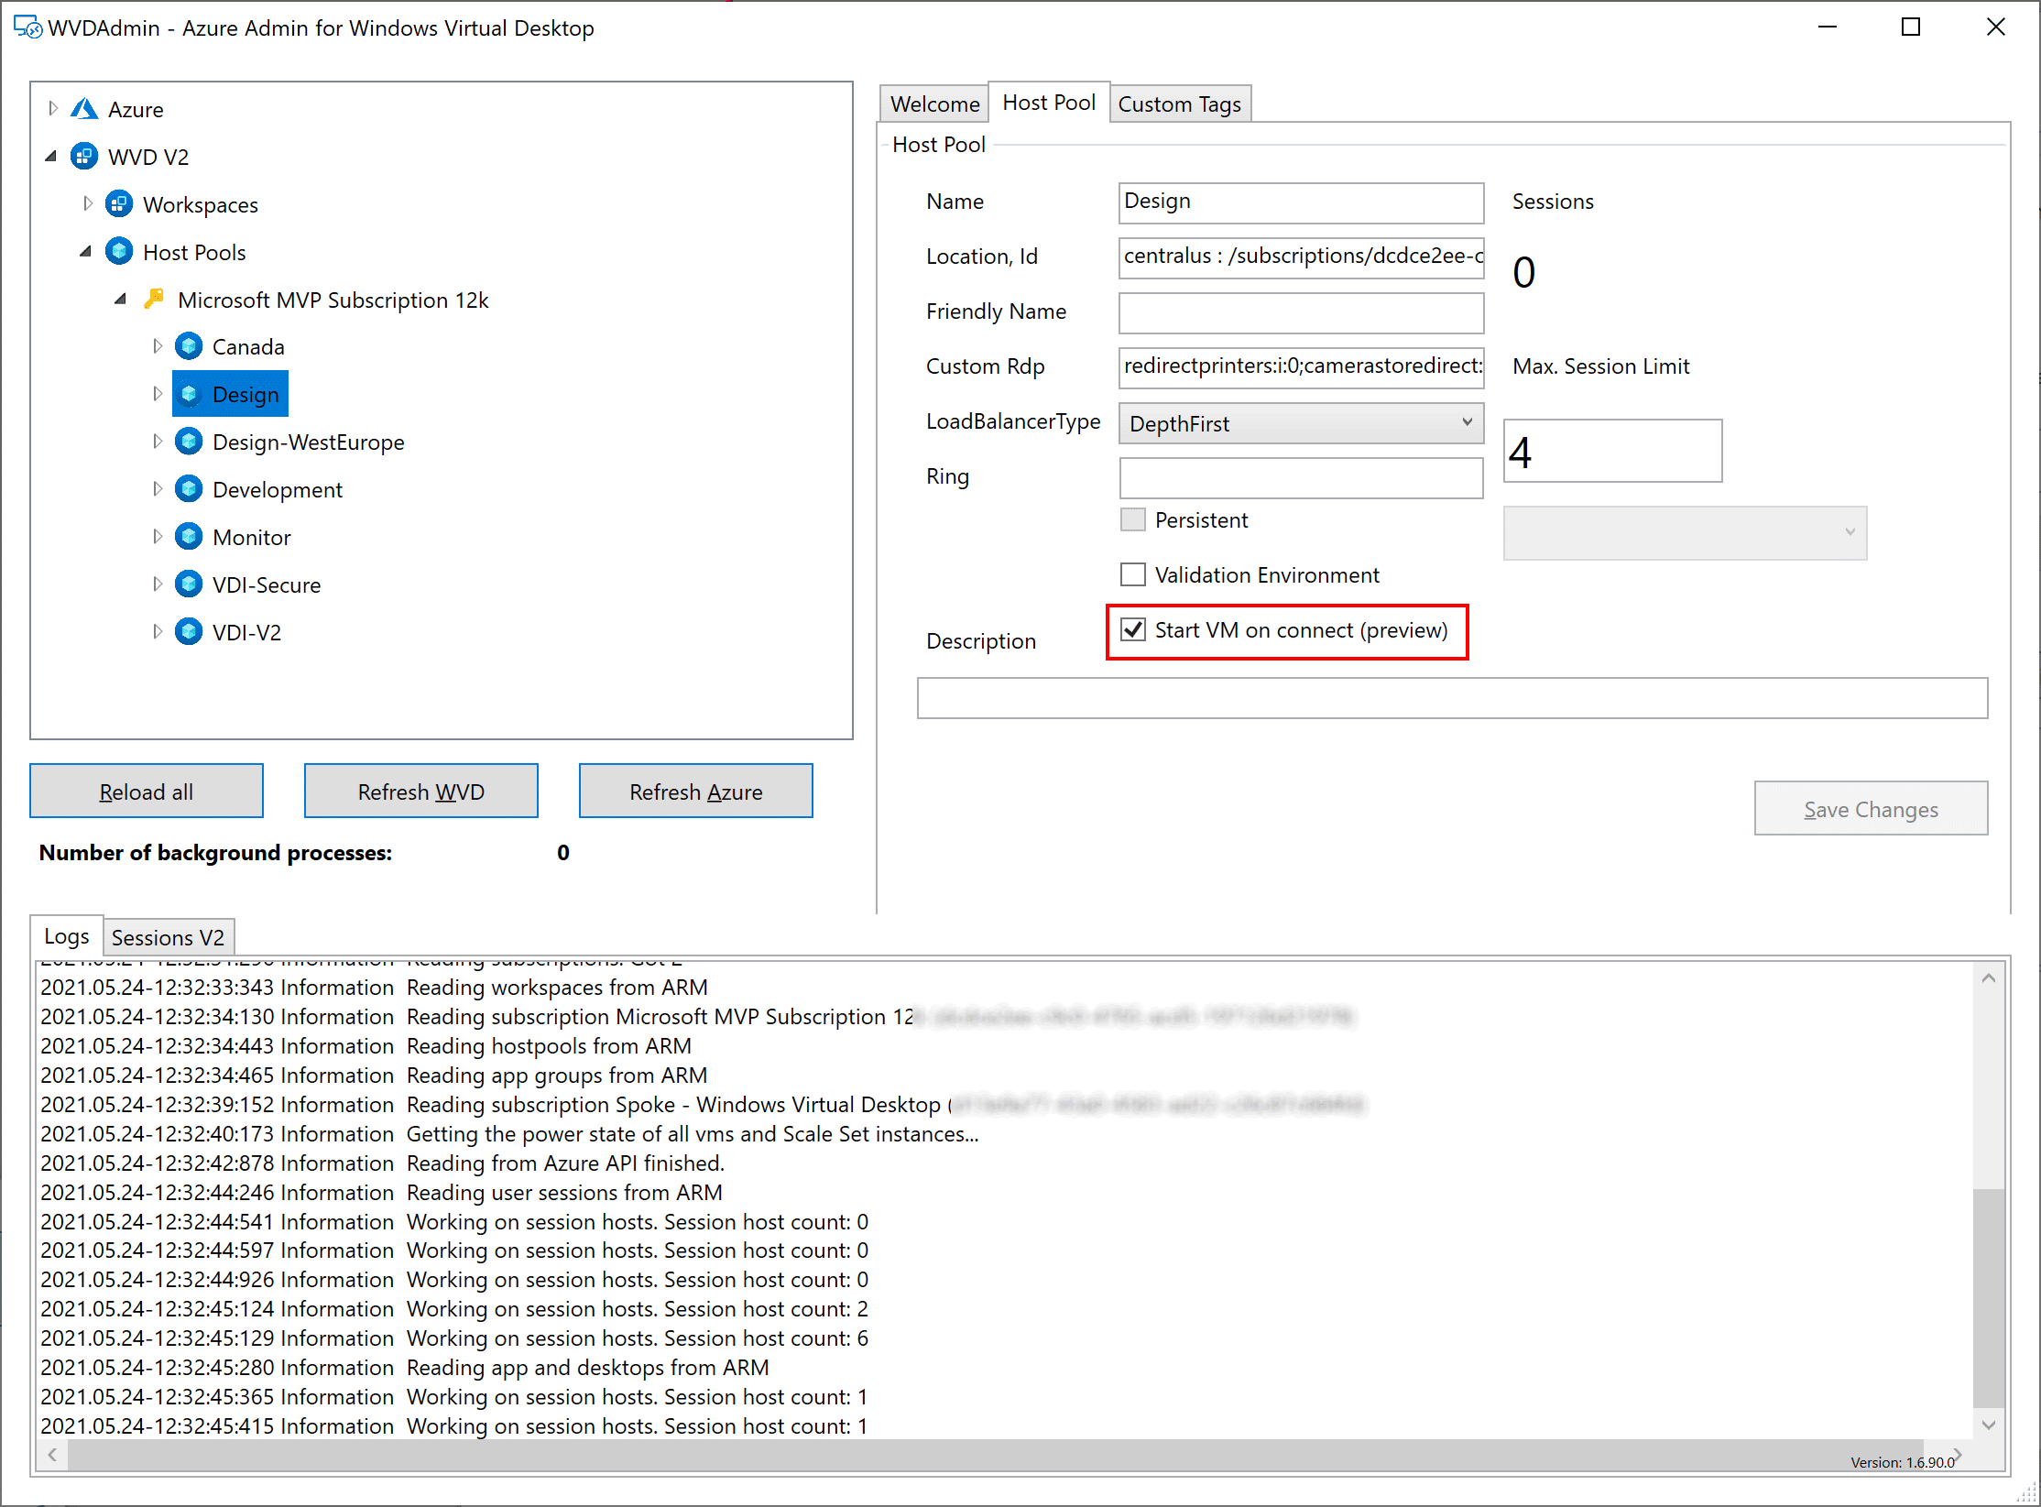

Power-On-Connect Feature in Windows Virtual Desktop Power-on-connect is in preview for assigned session hosts and pooled session hosts (multi-user host pool). With the new feature, users are triggering the start of the assigned session hosts or of a pooled on demand. That allows scaling up from zero hosts. Shutting down is omitted, but you can check my upcoming project to use power-on-connect with predictive autoscaling, including the shutdown of the hosts (and many other features). Check out my “preview” project “Hydra” at [GitHub](https://github.com/MarcelMeurer/WVD-Hydra).

You can enable power-on-connect for private host pools in the Azure Portal or with [WVDAdmin](https://blog.itprocloud.de/Windows-Virtual-Desktop-Admin/). [WVDAdmin](https://blog.itprocloud.de/Windows-Virtual-Desktop-Admin/) also allows enabling power-on-connect for pooled/multi-user host pools.

To use power-on-connect, you have to allow Microsoft to start virtual machines. To do that, create a custom role with the following link and add the *user* “Windows Virtual Desktop” with this role to the resource group containing the virtual machines.

Install the power-on-connect role

Learn more at: <https://docs.microsoft.com/en-us/azure/virtual-desktop/start-virtual-machine-connect>